Request for authorisation for images of nuclear facilities

Without the authorisation of the Minister of Interior affairs, satellite images of the sensitive nuclear sites of Belgium need to be blurred when commercially used.
Moreover, also making, publishing, exhibiting, selling, distribution or reproduction of images of the nuclear sites are prohibited without an authorisation.

Data applicant
Applicant:

Address applicant:

Contact details applicant:

Client (if not similar to the applicant):

Address Client:

Details of the request
This request concerns: (indicate what is applicable)
☐ satellite images
☐ aerial images
☐ pictures
☐ video-recordings

Purpose of the images:
☐ publishing
☐ exhibition
☐ selling
☐ distribution
☐ internal use
☐ other:

Why do you want to make these images?

This request concerns: (indicate what is applicable)
☐ Generic request (multiple purpose)
☐ Specific request (single purpose)
Dates and periods of making the images:

Concerned nuclear installation(s):

How will you make sure that no detailed images of the nuclear site will be distributed?

Specific for satellite images
Taken/planned measures to limit distribution:

In case of commercial reproduction of satellite images:
- What will you do to blur the images (more specifically concerning permanence, intensity and resolution)?

- Are there third parties that have a view of access to the (not blurred) images and reproductions for which you ask authorisation?
YES / NO

Your privacy is important. Read in our privacy declaration what we do with your personal information (GDPR | FANC - Federaal Agentschap voor Nucleaire Controle (fgov.be)).
Place:
Date:
Signature applicant:

Send this request to:
Minister of Interior Affaires
Wetstraat 2
1000 Brussels
info@verlinden.belgium.be
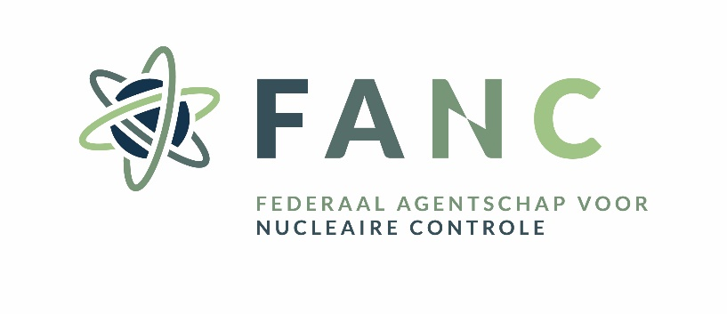
Cc: images@fanc.fgov.be

Belgoprocess, IRE, JRC Geel, Power plant of Doel and Tihange, SCK CEN
A generic request is understood as: a request for authorisation for a series of images or reproductions whose modalities are identical or comparable.

